Team Overview

Ranpura Yash | Admin Panel Development, Designing
Shah Amal | Admin Panel Development, Analysis
Shah Harshil | Admin Panel Development, Coding

Idea Overview
- Using these application people can complaint easily.
- Solution will be given easier.
- Anyone can see the map when they will open the application.
- They can search the area and see the series of poles there, after that they can select on poles and complaint about it.
- The objective of our definition is that if public sees that the street light is not working properly or any other problem then they can complaint in the application.
- On behalf of the complaint the government employees can easily detect the problem where pole is located.

Target Audience
We are targeting local public who faces problems about complaining defected streetlights

Study of Similar Ideas
There is no similar definition to solve street light complaint problem.
The complaints are registered manually through phone calls.
General public can make calls to amc department and registered their complaints.
But amc employees are facing difficulties in finding exact location of pole.

Market Research & Study of survey
- As per our market research there is no unique identification for street poles right now.
- We conducted the survey and found some problems regarding the complaint system that is not much digital right now, so our solution is going to help them out solve problems easily.
- As per the survey there is around one hundred thousand poles in whole Ahmedabad.
- In the current time AMC get the complaint via phone call.
- When complaint comes about the pole, AMC employees faces difficulties to find out that pole.
- They cannot identify the problem regarding the pole.

Database Design
Table Name: Admin_table

Field name | Data Type(Size) | Constraint | Description
admin_id | Int(11) | Primary Key | Unique id for admin table
Email_id | Varchar(20) | Not Null | Email of admin
Password | Varchar(10) | Not Null | password of admin

Table Name: Users

Field name | Data Type(Size) | Constraint | Description
users_id | Int(11) | Primary Key | Unique id for each user
Name | Varchar(20) | Not null | Name of user
Phone | Varchar(13) | Not null | Phone no. of user
Is_active | Int(2) | Not null | Status of user

Table Name: worker_table
Field name | Data Type(Size) | Constraint | Description
Id | Int(11) | Primary Key | Unique id of worker table
Name | Varchar(20) | Not null | Name of worker
Mobile | bigint(11) | Not null | Mobile no. of worker
Email_id | Varchar(30) | Not null | Emal id of worker
Worker_id | Int(11) | Not null | Unique ID of worker
Type | Varchar(20) | Not null | Type of worker
Is_active | Int(2) | Not null | Status of worker

Table Name: Pole_table

Field name | Data Type | Constraint | Description
pole_id | Int(11) | Primary Key | Unique id for each poll
Pole_char | Varchar(20) | Not null | Pole character
Pole_int | Int(5) | Not null | Unique Number on each poll
Area_name | Varchar(30) | Not null | Name of area
Ward_name | Varchar(30) | Not null | Name of ward
Pole_add | Varchar(100) | Not null | Address of pole
Asset_type | Varchar(30) | Not null | Name of asset (street light)
Bracket_type | Varchar(50) | Not null | Type of bracket (single/double)
Lamp_type | Varchar(30) | Not null | Type of lamp in walt
Longitude | Decimal(9,6) | Not null | longitude of pole location
Latitude | Decimal(9,6) | Not null | Latitude of pole location
Is_active | Int(2) | Not null | Status of pole

Table Name: Common_problems

Field name | Data Type(Size) | Constraint | Description
Com_prob_id | Int(11) | Primary Key | Unique id for common problems
Com_prob_name | Varchar(20) | Not Null | Name of the common problem
Is_active | Int(2) | Not Null | Status of problem

Table Name: Area_table

Field name | Data Type(Size) | Constraint | Description
area_id | Int(11) | Primary Key | Unique ID of area
area_name | Varchar(20) | Not Null | Area name
Is_active | Int(2) | Not Null | Status of area

Table Name: complaint_table
Field name | Data Type(Size) | Constraint | Description
complaint_id | Int(5) | Primary Key | Unique ID of complaint
Pole_number | int(11) | Foreign key | Unique pole number
Com_prob_name | Varchar(50) | Not Null | Name of the common problem
Description | Varchar(255) | Not Null | Common problem description
Is_active | Int(2) | Not Null | Status of complaint

Table Name: comp_assign_table

Field name | Data Type(Size) | Constraint | Description
Comp_id | Int(11) | Primary Key | Unique id for complaint assign table
Complaint_id | Int(11) | Foreign key | Unique ID of complaint
Id | Int(11) | Foreign key | Unique ID of worker table
Is_active | Int(2) | Not null | Status of assigned complaint
Table Name: Ward_name_table

Field name | Data Type(Size) | Constraint | Description
ward_id | Int(11) | Primary Key | Unique id for each ward
Ward_name | Varchar(20) | Not null | Name of particular ward
Area_id | Int(11) | Foreign key | Unique ID of area
Is_active | Int(2) | Not null | Status of ward

Table Name: Feedback_Master

Field name | Data Type(Size) | Constraint | Description
feedback_id | Int(11) | Primary Key | Unique id for feedback
Complaint_id | Int(11) | Not null | Unique ID of complaint
Description | Varchar(30) | Not null | Description of feedback
User_id | Int(11) | Not null | Unique ID of user

Use Case Diagram
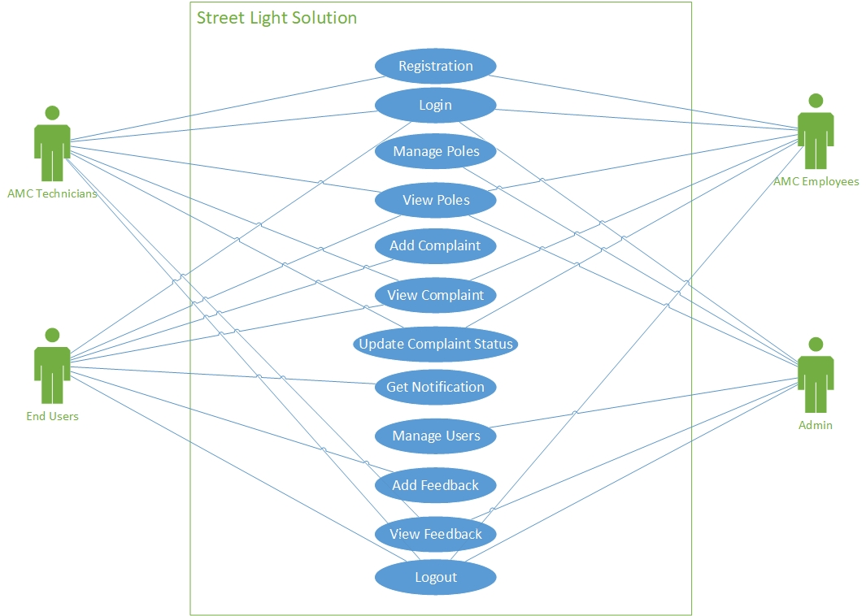

Activity Diagram
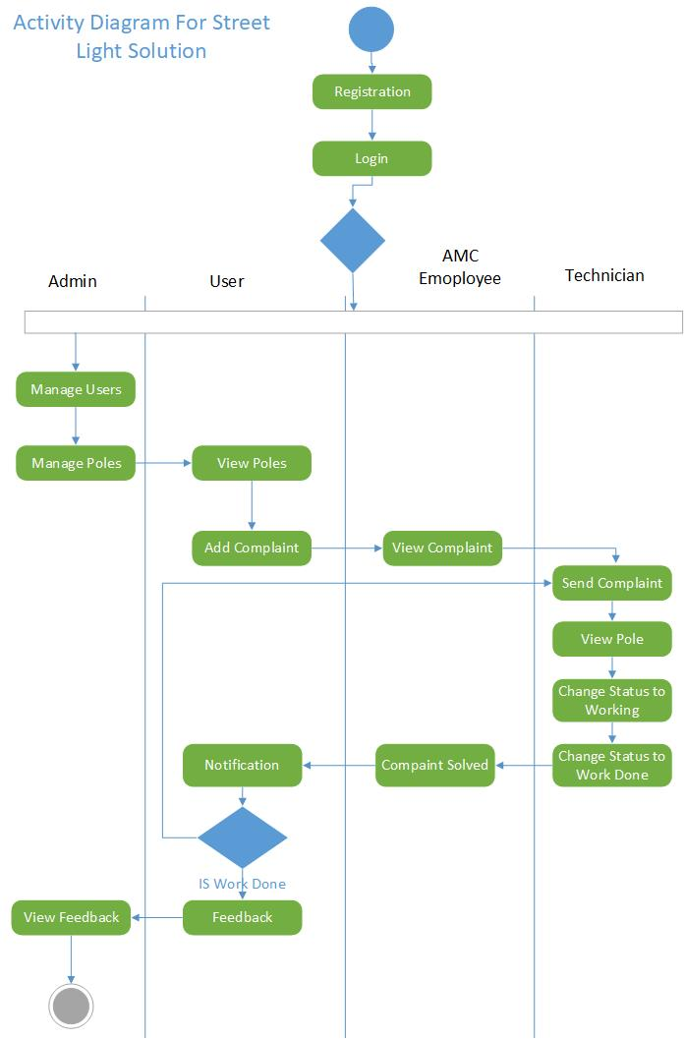

Class Diagram
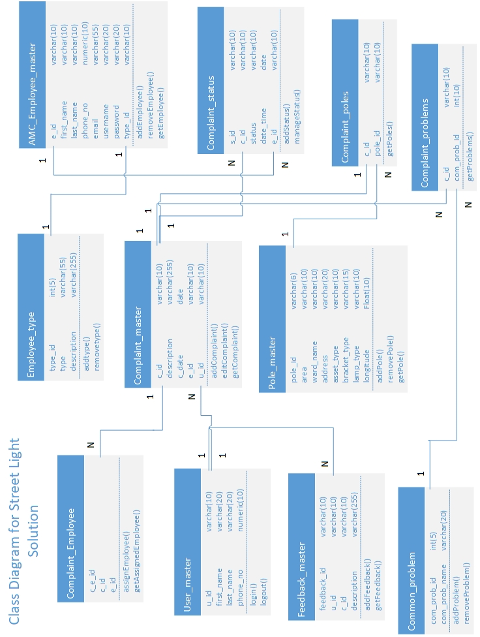

Dashboard page
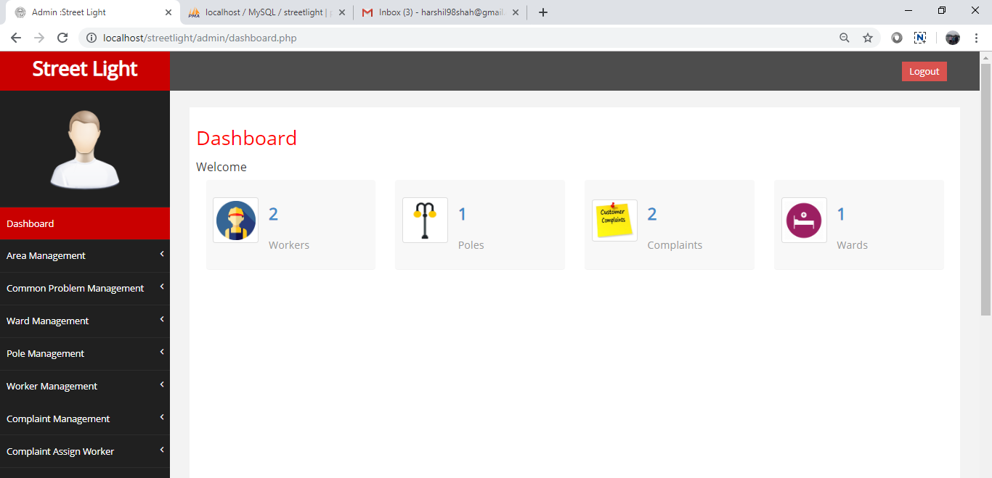
Description: Admin panel dashboard page.

Addarea page
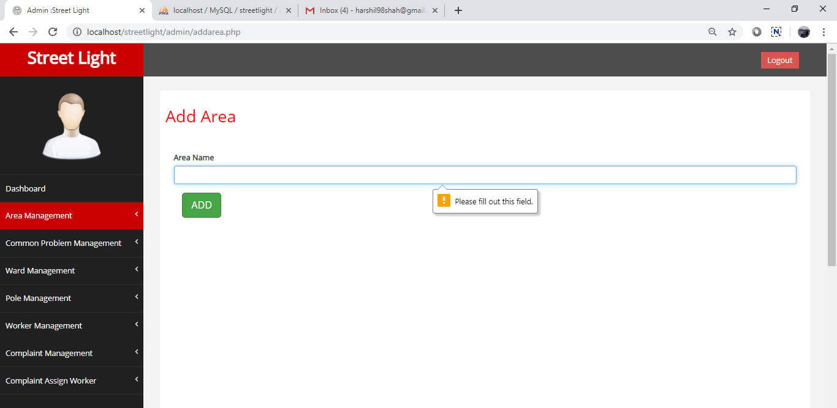
Description: Admin will add area.

Manage area page
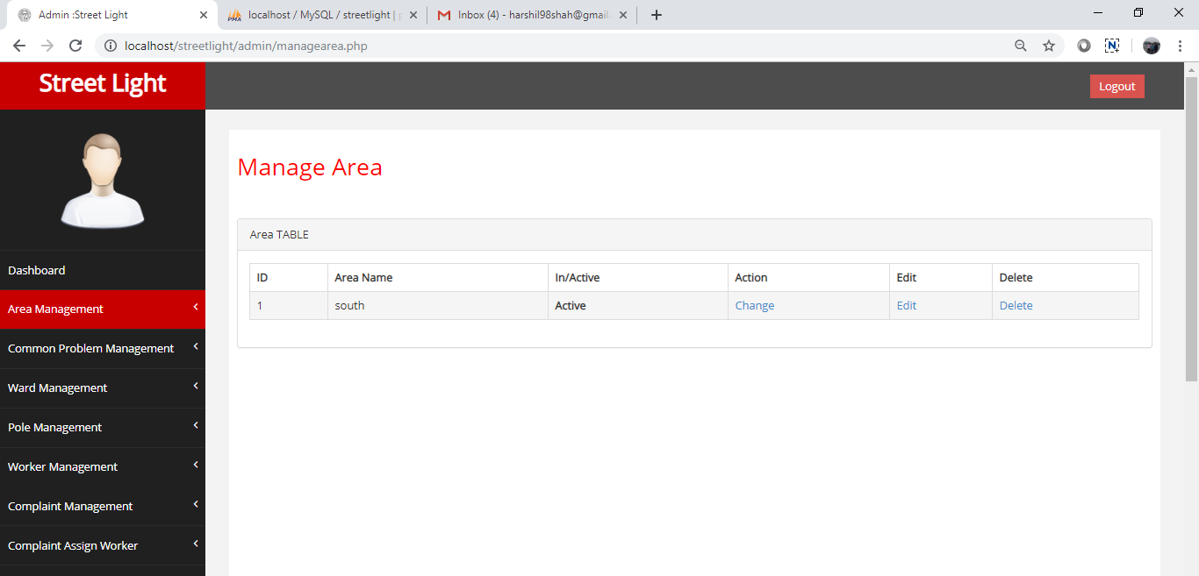
Description: Admin will manage area.

Add common problems page
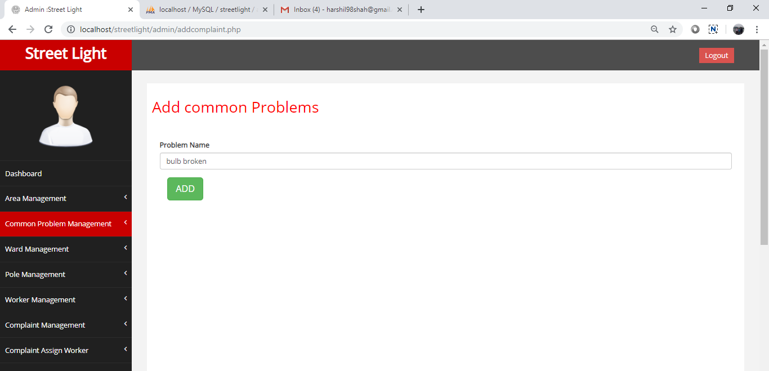
Description: Admin will add list of common problems

Manage common problem page
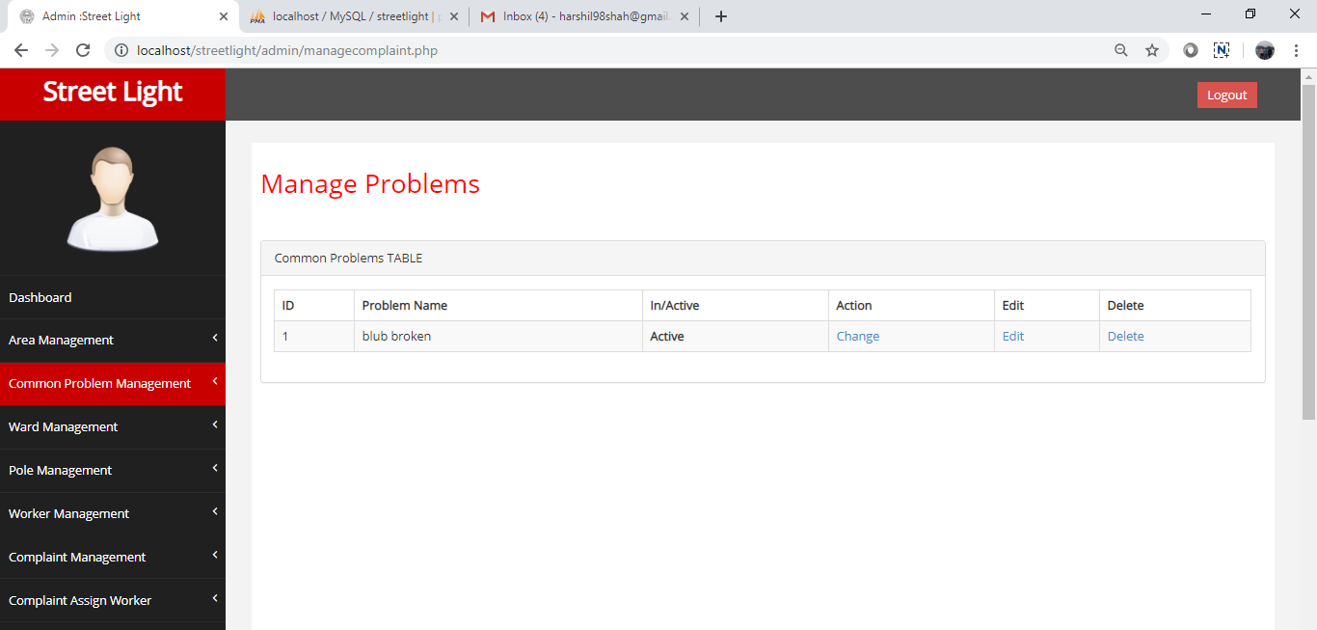
Description: Admin will manage common problem list.

Add ward page
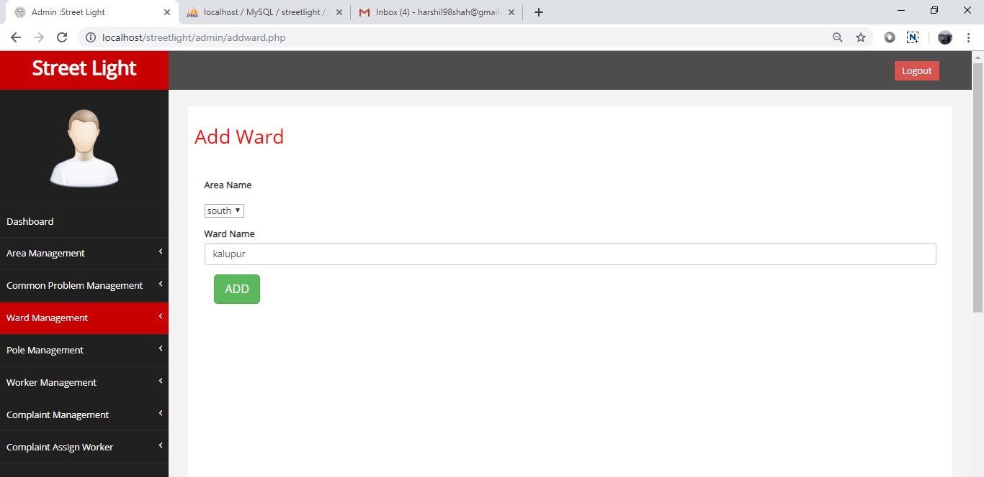
Description: Admin will add ward

Manage ward page
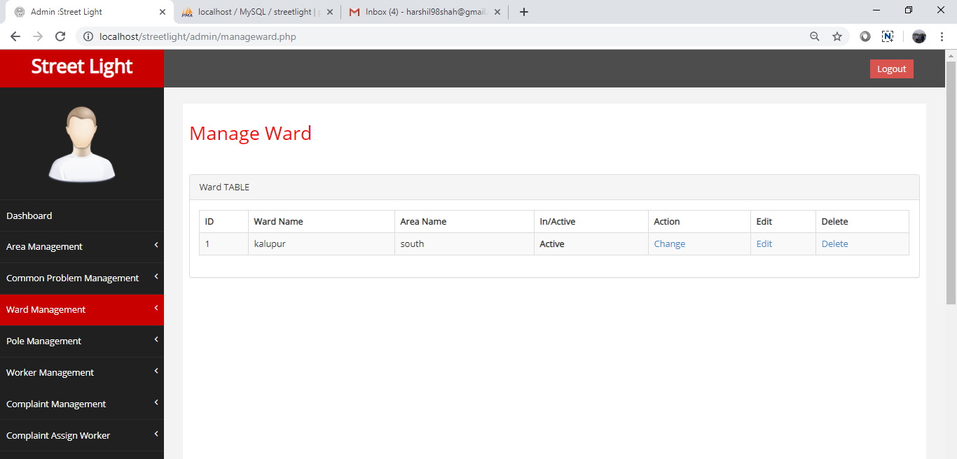
Description: Admin will manage ward details.

Add pole page
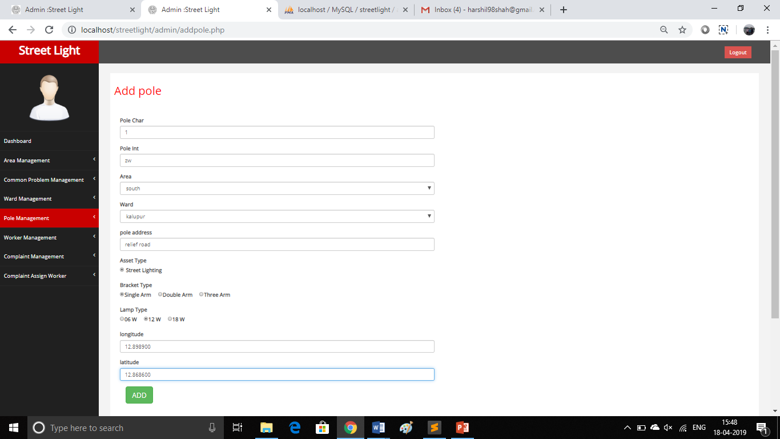

Description: Admin will add pole details.

Manage pole page
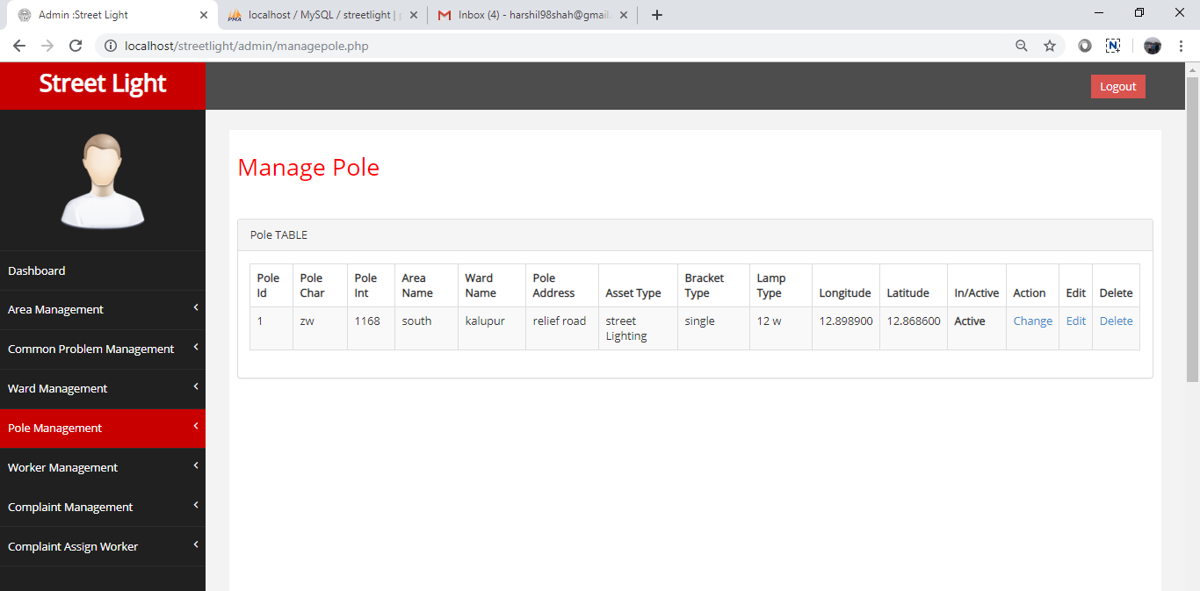
Description: Admin will manage pole details

Add worker page
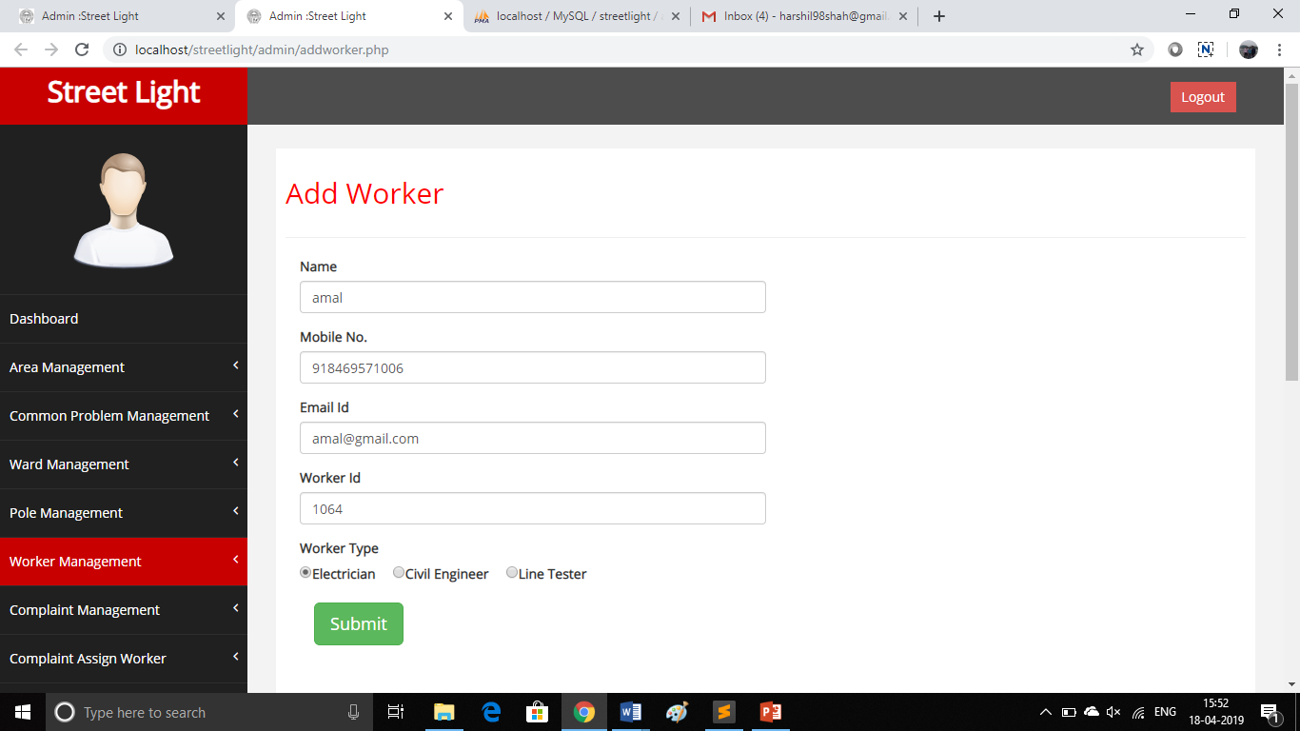

Description: Admin will add AMC worker details

Manage worker page
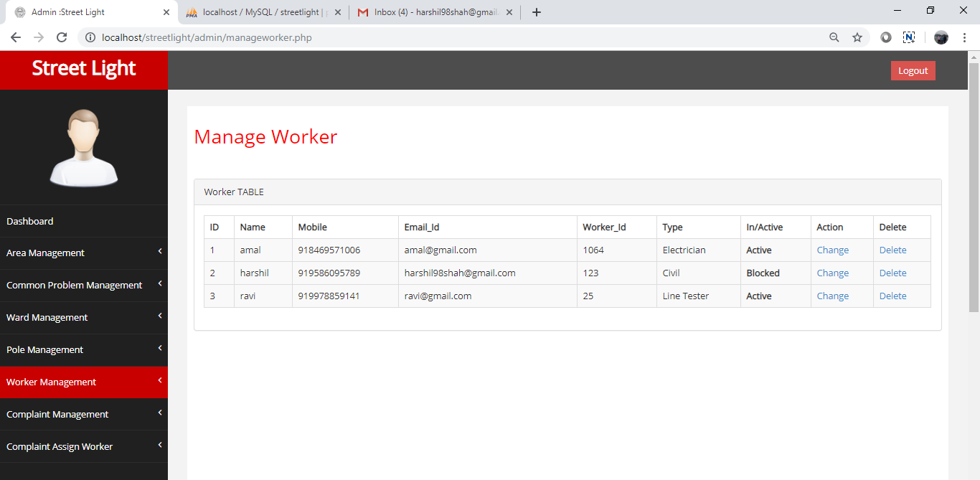
Description: Admin will manage AMC worker details

Assign complaint page
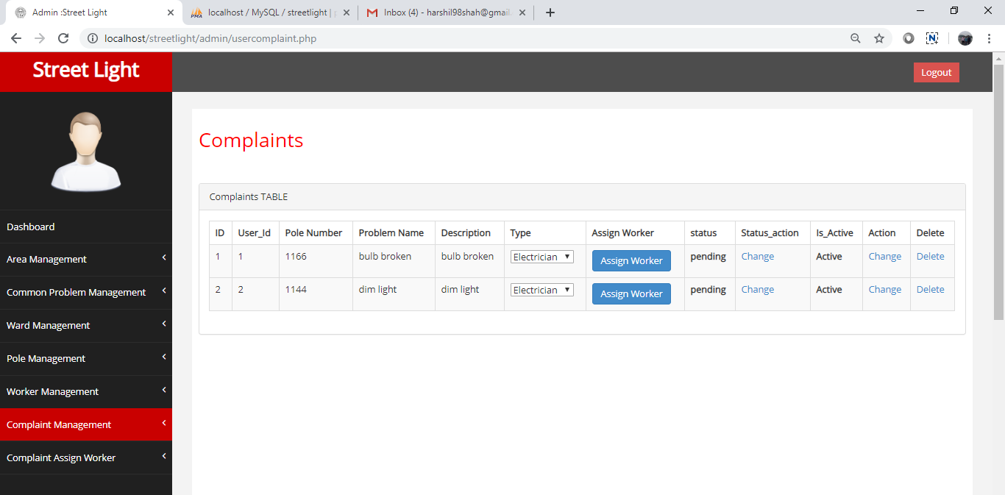
Description: Admin will assign complaint to worker and change status of complaint

Assign workers page
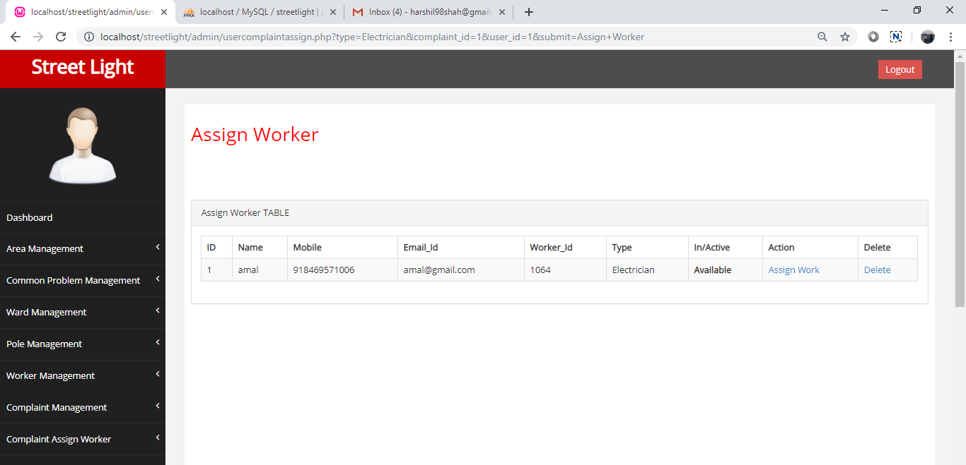
Description: complaint will be assigned to the worker

Complaint assign worker page
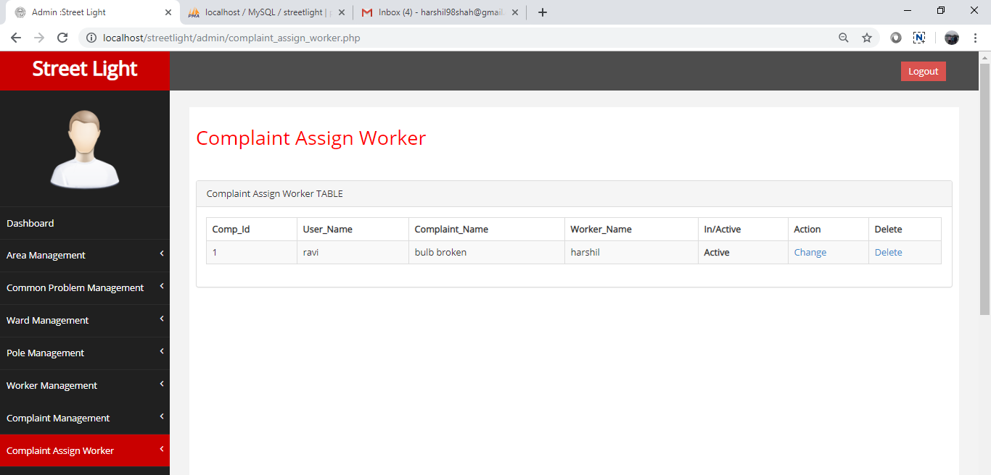
Description: Assigned complaint status details

Core Code Snippets
<form action="usercomplaintassign.php">
<td>
<select name="type">
<option value="Electrician">Electrician</option>
<option value="Civil">Civil</option>
<option value="Line Tester">Line Tester</option>
</select>
</td>
<td>
<input type="hidden" name="complaint_id" value="<?php echo $row['complaint_id']; ?>">
<input type="hidden" name="user_id" value="<?php echo $row['user_id']; ?>">
<?php
$is_active = $row['is_active'];
if($is_active=='0')
{
echo '<input type="submit" name="submit" value="Assign Worker" class="btn btn-primary" disabled />';
}
else
{
echo '<input type="submit" name="submit" value="Assign Worker" class="btn btn-primary">';
}

?>

</td>
</form>
<td><b><?php if($row['status']==25){ echo "pending";}elseif($row['status']==50){
echo "on View";}elseif($row['status']==75){
echo "on process";} else { echo "Completed";} ?></b></td>

<td><a href="actionstatus.php?id=<?php echo $row['complaint_id']; ?>&
status=<?php echo $row['status']; ?>">Change</a></td>

<th><?php if($row['is_active']==1){echo "Active";}else{echo "Blocked";} ?></th>

<td><a href="actionusercomplaint.php?complaint_id=<?php echo $row['complaint_id']; ?>&status=<?php echo $row['is_active']; ?>">Change</a></td>
<!--<td><a href="editusercomplaint.php?complaint_id=<?php echo $row['complaint_id']; ?>">Edit</a></td>!-->

Future Directions
We decided to go with developing some hardware chipsets which can detect the problems happened in the pole.
The problem which is detected is shown to the respected government employee in a website.
Also, we are developing AI based application, which helps to provide direct solution.

Appendix, List of Abbreviations and References
AI – Artificial Intelligence
Hardware chipset – One type of chip that identify direct updates on
particular server.

Reference :-
1:- www.w3school.com
2:- https://ahmedabadcity.gov.in/portal/index.jsp
3:- https://www.stackoverflow.com

